Episode 6: Next to the Blue Anchor
In this episode you might come across some new words. Here are some we thought were interesting:
Architecture – the art and science of planning, designing, and constructing buildings

As you are listening:


Jot down things you find interesting…



What types of shops are mentioned in this episode?


Discuss your answers as a class.
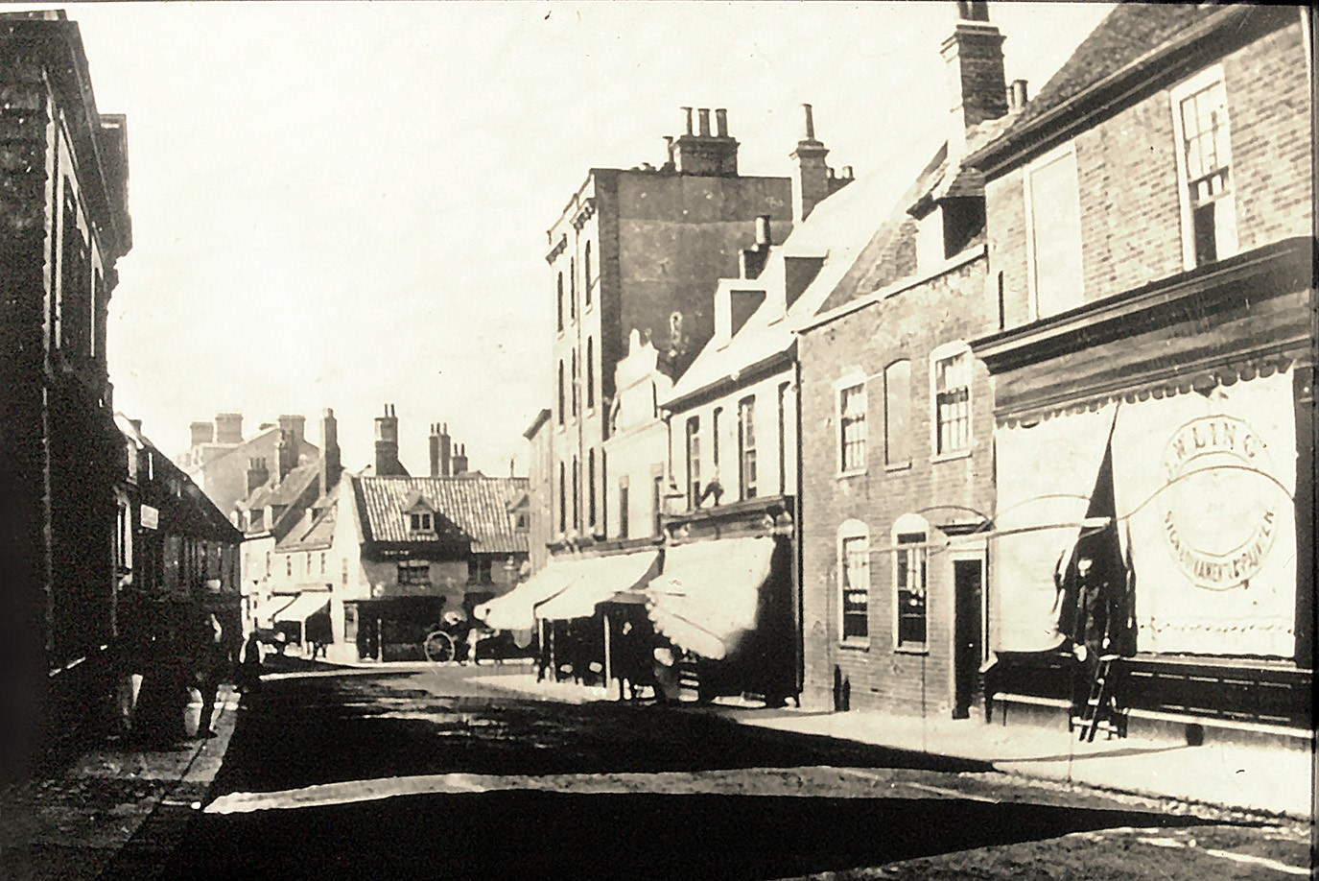
Lowestoft's High Street in the 1870s
© Jack Rose Collection

Photographs give us a chance to time travel, looking at how we lived in the past.
What do you notice that is different?


What would be in the street now that isn't there in the 1870s?




What would you see, what would you hear?

What would you miss that wasn't invented or available in the 1870s?



Write a four-line poem about time travelling back to this photo:

First line about a door,
Second line about a window,
Third line about the street,
Final line about something that isn't there

Example:
Time Travel to the 1870
I knock on the door and a man answers in a suit and hat with a big beard
I look in the shop window and want to buy
I walk down the street and hear a horse and carriage
I can't find my mobile phone and couldn't get a signal anyway.

Door:

Window:

Street:

Something not there:

