Episode 1: Top end of the High Street
In this episode you might come across some new words. Here are some we thought were interesting:
Demolish – pull down or knock down (a building)
Render – a first coat of plaster applied to a brick or stone surface.
Mishmash – a confused mixture, jumbled up.
Historian – an expert in history, usually focusing on a time-period or location, for example Ivan’s focus is on Lowestoft


As you are listening:
Jot down things you find interesting…


What types of shops are mentioned in this episode?




Discuss your answers as a class.

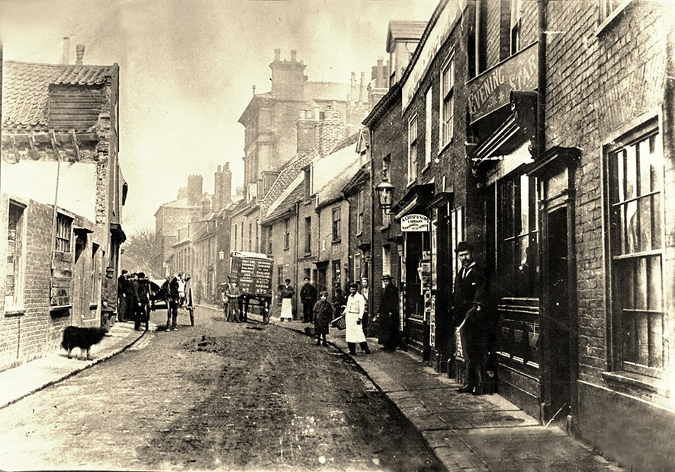
The top end of Lowestoft's High Street in 1897.
© Jack Rose Collection

The street is full of people who are posing for the photograph, all standing still and looking towards the cameraman.
How many people and animals can you spot?


Who are the people and what sort of jobs do you think they do?


Choose four of the people or animals that you can see in the photograph and create a poem by writing a line about each of them:

Example:
The dog is about to steal a sausage from the butcher's shop
The horse looks forward to going home down hill
There's a delivery man but no-one's at home to answer the door
And there's a man standing in the doorway of the 'Evening Star', waiting for the postman

